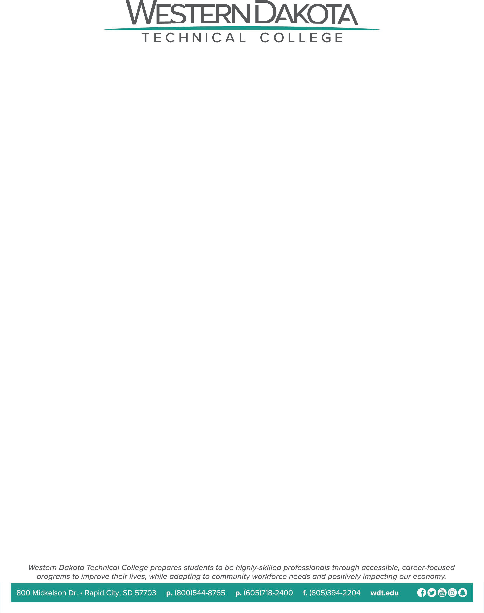

Notice of Quorum

Pursuant to SDCL 1-25-1, notice is hereby given that a potential quorum of Board of Trustee members will be present for the college events below. Official board action will not be taken.

October 21, 2026, 2:00 p.m., Legislative Open House, WDTC Event Center
October 21, 2026, 6:00 p.m., Social with South Dakota Board of Technical Education, Pour 54 Taphouse (615 Main St, Rapid City, SD 57701)
October 22, 2026, 8:30 a.m. Joint Meeting with South Dakota Board of Technical Education, WDTC Campus – Pennington County Room
October 22, 2026, 6:00 p.m. WDT Foundation Gala, WDTC Event Center

